PPFS
Team 9: EnGR 339/340 Senior design Project Calvin College
Trenton Wells, Dan Michaels, Tommy Matheson
2017

© 2017, Calvin College, AvaSure LLC, Daniel Michaels, Thomas Matheson, and Trenton Wells

Executive Summary
This document provides a detailed description of Team 9's senior design project. The project was proposed by AvaSure, a leading firm in the development of hospital based telemonitoring systems. The team is designing a wireless alarm device, called the remote stat alarm (RSA), that will have the ability to connect to an existing line of telemonitoring stations that have already been released by AvaSure. The alarm device will hang above a hospital door, and the alarm will be indicated by a flashing light. It will connect to the existing station via Bluetooth and this connection will be facilitated using near field communication (NFC). Additionally, the team will be using a Raspberry Pi to emulate the AvaSure monitoring unit.
So far, the team has written a program for the Raspberry Pi that allows the Bluetooth address of a smartphone to be read from an NFC card and then passed to BlueZ, the Linux Bluetooth stack on the Raspberry Pi. Bluetooth pairing is then initiated using PulseAudio, a Linux daemon that enables music streaming. In the future, this program will be updated to be applicable to the RSA and to enable alarm indication activation. The team has also begun work in testing power schemes for the RSA by evaluating a charge controller and solar panels.
Through this development, the team has learned that there is a significant learning curve when dealing with Linux stacks. Through research the team is confident they will be able to start making progress on the software for both the Raspberry Pi, and the RSA. The team has also found that, based on expected usage data, indoor solar energy harvesting should be adequate to keep the unit powered for at least a year. Moving forward, the team will continue researching components and technologies, design the system hardware, and implement testing and conformity. This document contains information regarding progress on these fronts, and plans to continue progress.

Table of Contents
1. Introduction 3
1.1 Project Description 3
1.2 Project Scope 4
1.3 The Team 4
2. Project Management 5
2.1 Team Organization 5
2.2 Schedule 5
2.3 Budget 5
2.4 Method of Approach 5
3. Requirements 7
3.1 Interface Requirements 7
3.2 Functional Requirements 7
3.3 Performance Requirements 7
4. Schedule and Task Breakdown 9
5. System Architecture 10
5.1 Raspberry Pi System Implementation 11
6. Design 12
6.1 Design Criteria 12
6.2 Design Norms 13
6.3 Design Decisions 13
7. Testing 15
7.1 Development Kits 15
7.2 Prototype Testing 15
7.3 Software Testing 15
7.4 Electromagnetic Compliance Testing 15
8. Conclusion 16
9. References 17
10. Appendix 18
10.1 Appendix A: 18
11. Acknowledgements 19

Table of Figures
Figure 1 AMU in patient room 3
Figure 2 Hardware Block Diagram 10

Introduction

Project Description
When a hospital patient takes a fall, it can have a major impact on the physical and emotional health of the patient, and cost the hospital tens of thousands of dollars. AvaSure LLC has developed a solution to help mitigate this problem, called the AvaSys® Telesitter system. The system allows a technician to remotely monitor multiple patients at once, and alert on-floor workers if a patient is at risk for a fall. This monitoring is enabled using an AvaSys® Mobile Unit (AMU), a movable tower with a camera on it that streams live video footage from the hospital room of an at-risk patient to a monitoring station. Figure 1 shows what an AMU looks like when setup in a patient room.

When a patient is at risk of falling, the technician can activate a "stat" alarm on the AvaSys® Mobile Unit (AMU) to indicate that an on-floor nurse needs to step in. The alarm currently consists of a loud tone playing directly out of the AMU. However, this can turn out to be confusing for responding nurses, because there are times when rooms that are next to each other each have AMUs inside of them. When the audible stat alarm is activated, nurses can hear the alarm, but have trouble determining which room needs a response, and this leads to decreased response times.

Our project is to design a remote stat alarm (RSA) indicator that will be placed in the hallway outside of each hospital room that has a monitoring unit. The device will use ultra-bright LEDs to quickly indicate to a nurse which room has the patient that needs intervention. This will cut down on the time between the stat alarm activation and the physical intervention, potentially increasing the chance of successful fall prevention.

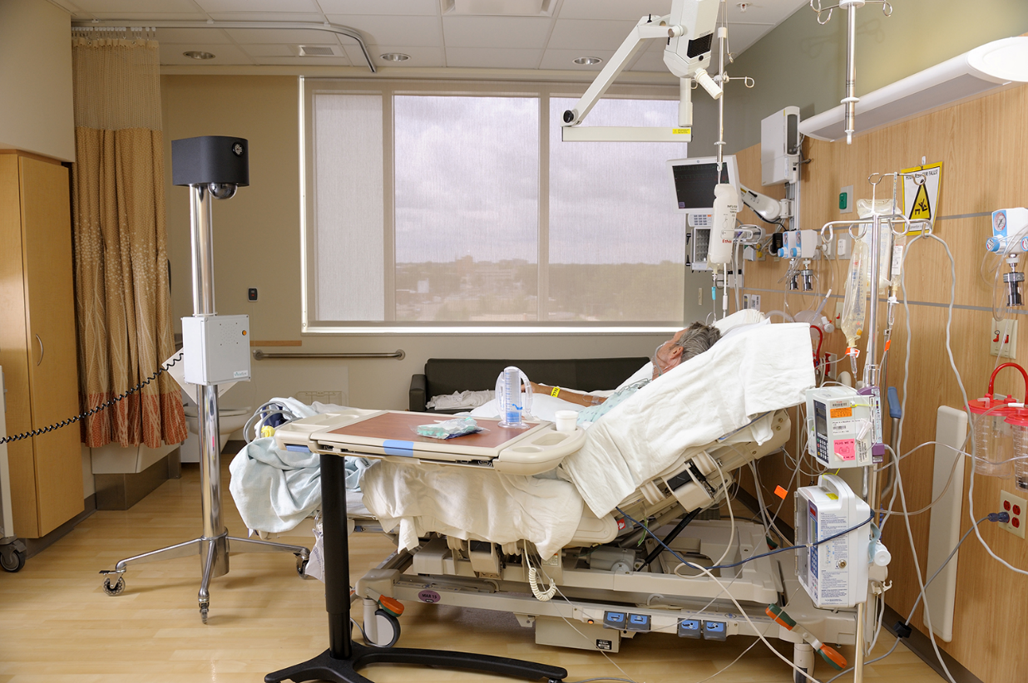
Figure 1 AMU in patient room

Project Scope
The project timeline is eight months, starting in October 2017 and continuing to May of 2018. Ben Moes, Electrical Engineer at AvaSure, is the technical advisor of the project team, meeting as needed with the team. The student team is composed of Daniel Michaels - Hardware Engineering Co-Op within the Product Engineering Team at AvaSure– and his two teammates, Tommy Matheson and Trenton Wells. The team expects to have a functioning prototype of the RSA that will pair and be controlled by a Raspberry Pi for demonstration purposes. A prototype housing for the unit is also requested.

The Team
Daniel Michaels
Daniel Michaels is currently the Hardware Engineering Intern/Co-Op on the Product Development Team at AvaSure. After graduation, he will be joining GE Aviation in Grand Rapids as a part of the Edison Engineering Development Program. He enjoys playing music and running. One day he hopes to incorporate his passion for embedded systems and music into a career.

Trenton Wells
Trenton Wells is currently an Electrical Internal Development Intern at ADAC Automotive. He enjoys reading and is an amateur blacksmith in his free time. His passion for making and learning blends into his profession and he enjoys keeping up on the latest technology and innovations.

Tommy Matheson
Tommy Matheson is currently a Controls Engineering Intern at Dematic North America. He is also an amateur DJ, and this, sparking a love for music equipment and technology, helped lead him down the path of electrical engineering. Apart from his engineering life, Tommy is an avid swing dancer and rock climber.

Project Management

Team Organization
AvaSure, as the project sponsor, has given the team the guidelines for the project and is the team lead for project direction and specifications. However, the team has been given a great deal of autonomy and self-management as to how the goals are met and which member of the team meets them. The team is performing the design research, implementation, and feasibility studies of the project.
In addition to support from AvaSure, the team has many external resources that have made themselves available to help. Through the senior design class, the group has been paired with Professor Mark Michmerhuizen, who is serving as a mentor and acting as the recipient of the assigned deliverables. An industrial consultant, Eric Walstra, has also agreed to meet with the team, and has been guiding them on project timelines and is available to offer any other help deemed relevant.
The team has decided to host team documents on a Calvin College SharePoint site. This was chosen because of the integration with the full Microsoft Office 365 software package. This allows the team fluid collaboration options and access to all files, both in the cloud and locally. The site allows for consolidated storage of the team's written reports and presentations. It also contains a research folder where relevant external documents, like chip datasheets, are kept.

Schedule
For the scheduling of tasks and estimating completion time, the team originally opted to use GanttProject, a free alternative to Microsoft Project that could also be imported into Microsoft Project. This allowed full integration with the SharePoint site and instant access to the team schedule and current tasks through the cloud. There were some limitations to this approach, because the team was not familiar with the operation of this scheduling software and lacked experience in estimating task completion times.
After consulting with Walstra, it was decided that the team would be more successful using major milestones to track progress rather than a Gantt chart. The advantage of this is that it ensures that the team is staying on track, without requiring the maintenance of an overly detailed scheduling system. With a small team and only a few tasks at a time this approach relieves the stress of a more rigid schedule as the time required for a task is not completely understood. The team has estimated that the time required for each of the members per week is 4-6 hours to meet the milestones we have placed for the next section of the project.
So far, the team has been finding success in this approach, and has been checking off the milestones as they have been met. This approach has also helped in future estimations of time management and will influence the rest of the time management decisions accordingly.

Budget
The budget is managed by AvaSure and when the team needs to purchase an item the team files a purchase order with them. The team has not been given a defined budget but AvaSure has expressed that given logical reasoning for a purchase, it will be made for the team.

Method of Approach
The design methodology is based on the team’s previous experience as research engineers for their respective employers. This has provided a well-formed basis for work and has been instrumental in allowing for much of progress thus far. The team’s main form of communication has been face to face meetings during class time and outside of that time. Electronic means of communication have included Facebook Messenger and email. Both methods provide records of the conversations for future reference and referral.

Requirements
Redacted by AvaSure LLC.

Interface Requirements
Redacted by AvaSure LLC.

Functional Requirements
Redacted by AvaSure LLC.

Performance Requirements
Redacted by AvaSure LLC.

Schedule and Task Breakdown
The project is broken down into several key stages and sub stages. This allows the team to be agile and productive when a single task encounters a delay. The task breakdown lays out a hierarchy for level of completeness on different stages of the project. The major milestones are research, design, development, and testing.
The research section is at 80% completion and will remain open as we encounter problems and need to understand ways in which we can overcome them. The main goal of the research section is to develop an understanding of the technologies that are implemented in the design. The research phase is split into five separate sections: Bluetooth, Near Field Communication (NFC), Solar Harvesting, Battery Management, and LEDs. These different sections were researched in parallel by the team and have resulted in a great deal of information and design options. The research documents are provided in the Appendix. The remaining time will be spent developing a greater understanding of the information and a deeper view of how a single system can utilize all the options.
The design phase began after the initial research was assembled and consists of five sections: hardware design, software, power requirements, housing design, and documentation. The hardware design phase is moving along however is only at an estimated 10% completion due to the high learning curve of new technology. This is estimated to greatly speed up as the initial challenges are overcome and the design process gets farther along. Software may well be the largest challenge and time-consuming factor of the design as the process continues. The plan has accounted for this and has allocated time and resources to the entire task. The other parts of design are meant to be done in parallel with the software stage and as these stages are completed the resources will be diverted to the software stage.
During a team meeting it was determined that another section of the design stage needed to be added. This stage consisted of developing a system that can emulate the functionality of the AvaSure Telesitter system. This system was determined as a need by the team because of the agreement that was made by the team and AvaSure, in the form of a non-disclosure agreement (NDA), to effectively demonstrate the system upon completion.
Development and testing stages are also meant to be done in parallel as there is a lot of overlap that must be done on the prototype and any subsequent revisions. The team has scheduled at a minimum of two prototype builds to be done and for electromagnetic compliance (EMC) testing to be conducted before the finial deliverable design is given over to AvaSure. This will encompass testing to the UL EMC requirements specified in the Appendix.

System Architecture
Redacted by AvaSure LLC.

5.1 Raspberry Pi System Implementation
Due to disclosure protected reasons, the AMU had to be emulated. The decision was made to use a Raspberry Pi from an NXP NFC Dev Kit for this purpose. The reason behind that was simply availability. The unit had already been purchased and was available for the team to use immediately. Were that not the case, the team could have considered using an Arduino or similar microcontroller kit. A few advantages the Raspberry Pi provided was an included NFC Shield, built-in BLE, and, because it is a mini computer, it provided a user interface for easier development and better control for demonstration purposes.
The MCU on the Remote Stat Alarm will be controlled via Bluetooth by the Raspberry Pi. Once the two devices have been paired, the Remote Stat Alarm will be triggered by a signal delivered via Bluetooth from the Pi, much like toggling an I/O. In addition, the RSA will periodically transmit its battery status back to the Pi. On the software layer, the Raspberry Pi will act as the controller for the system. Several languages including C and Python will be used to do the behind the scenes work of negotiating pairing, monitoring the RSA battery, and activating the RSA alarm action. The actions of the Pi will be user-controlled through a GUI.

Design

Design Criteria
Components:
Redacted by AvaSure LLC.

Design Norms
All of the design norms must be fulfilled in order for our project to be a success. That said, the following have been especially relevant to our design.

Delightful Harmony – It is important for our design to be beautifully simple and intuitive. When it comes to the hardware design, a minimal selection of parts in a simple layout would be desired. This is the reason that we chose to go with a chip that has an integrated Bluetooth module. On the software side of things, we are choosing to facilitate the Bluetooth pairing using NFC. This will make the product easy for the end user to operate, and be a natural step in the fall-prevention process.

Stewardship – Incorporating sustainable elements into the design such as solar power and low power systems decrease the impact of the device on the environment, and are greatly desired. If we can get our device to run solely off the ambient light in the hospital hallways, it will mark a great success in terms of power sustainability.

Justice – The design should be good for all involved parties, including the stakeholder. This means that the design should use components that are suitable and economical. Alternatives should be considered for components that are deemed too powerful for the job. This is an aspect that will be continued to be considered as the project moves along. Currently, we are aware that some components, especially the microcontroller, are too powerful for the job, and for production purposes, there may be more economically viable options.

Design Decisions
A number of design decisions were made regarding the system architecture and system hardware chosen.
Solar Power
In order to incorporate sustainability into our system, and to also introduce the potential for a perpetually charged device, a method of charging our battery while the device was in use was sought. The only real choice for this was to harvest ambient light from the hospital hallways using solar power. An alternative would be having the device plug into a wall outlet, but this would decrease the usability of the device, make above door mounting difficult, and not lend itself to sustainability.
Bluetooth LE
Bluetooth LE is a form of Bluetooth protocol that uses lower power than standard Bluetooth protocol. Since the design needs to have a minimal power drain over time, it was an easy choice to go with this protocol. Additionally, with a lower powered system, the design becomes more sustainable. Lower power components are more expensive, but are necessary to achieve the performance requirements as detailed in section 3.3.

Microcontroller Choice

When deciding which MCU to use in the project, a number of options were available. We ended up going with a powerful Texas Instruments MCU that has an integrated Bluetooth transceiver/receiver module. Another leading option was a utilizing a two-IC system involving a Microchip PIC and a separate Bluetooth IC, which would have a comparable cost. However, for our project scope, we decided to go with the simpler option and use one chip instead of two. The development tools provided with the TI MCU also seemed to be more complete and well documented.

Testing

Development Kits
The team started analyzing available products by purchasing development kits and samples from several different sources. The teams first kit was the SimpleLink™ CC26x2 wireless MCU LaunchPad™ Development Kit. This kit provides extensive labs and instruction material on the given product. This allows the team to be confident in the product specifications and implementation procedures before expensing a prototype. The team also plans to test the Ultra-Low Power Management IC and solar panel options for use in power management and energy harvesting.

Prototype Testing
The team plans to develop a prototype testing plan that will be included in the schedule breakdown. This plan will include hardware verification, software verification, functional testing for enclosure and LEDs, and power management testing. These tests will receive full test plans once the project get closer to these sections.

Software Testing
Software testing will consist of several iterations of team reviews and meetings. In these meetings, the code will be reviewed line by line and the developer will need to provide detailed reasoning behind the style, usage, and implementation documentation. This will be coupled with the prototype testing where the device will be loaded with the software and it will run through several usage tests.

Electromagnetic Compliance Testing
The team will be taking the design through the first stage of electromagnetic compliance (EMC) testing with E3 Compliance out of Grand Rapids, Michigan. E3 Compliance has the equipment and personnel trained to provide design guidance and full UL compliance reports that are within the scope of the project. EMC testing will provide the team information regarding the electromagnetic interference that the device creates and is susceptible to. This will allow us to be confident in the robustness of the design and knowledge that it will be safe for use in a hospital setting where there are life critical devices.

Conclusion
This project will require the team to use everything they have learned through their school and work experiences as a base of knowledge. Many of the components used for this project are outside the realm of expertise of the team and have required thorough research and practice to gain a working understanding of. Some of the most researched topics thus far have been programming microcontrollers and learning wireless communication protocols. A large amount of work and research has gone into writing programs to be run on the Raspberry Pi platform. So far, there have been several lessons learned, and areas of struggle. A tough reality for the team has been finding documentation for the man programming stacks and software development kits. Some lack documentation, and others suffer from very poor documentation. Nevertheless, the team is determined and knows that it will find the solutions necessary to deliver a product that meets the requirements.

References
NFC Forum. (2014, January 9). Bluetooth® Secure Simple Pairing Using NFC.
Texas Instruments. (2013, March). bq25570 Nano Power Boost harger and Buck Converter for Energy Harvester Powered Applications. 0-36.
Texas Instruments. (2016, December). CC2640R2F SimpleLink™ Bluetooth® low energy Wireless MCU.

Appendix

Appendix A:
Redacted by AvaSure LLC.

Acknowledgements
AvaSure - for their financial support and technical mentorship, as well as for their trust in our team to help with their development.
Mark Michmerhuizen – for his continued feedback and guidance on the project, and for challenging us to increase our scope further than we had initially thought.
Eric Walstra – for encouragement and affirmation in our design process and goals, and for feedback on project management.

See report in Appendix A.
See Schedule in Appendix A.
See Appendix A.
See UL Specifications in Appendix A.
Document included in Appendix A

