South Sudan is known for its large production of sesame. However, as the country lacks the industrial capacity to produce sesame oil, most of its sesame oil is made on a small scale and farm to farm basis. The current situation in South Sudan inspired our team to design an industrial chemical plant that produces 10,750 tons of sesame oil per year. This capacity corresponds to 1% of the worldwide sesame oil production
The objective of our project is to design a plant producing sesame oil from seed via mechanical pressing followed by solvent extraction.Sesame seed contains 50 wt % oil. We chose n-hexane to be our solvent on account of its high volatility (in contrast to the oil), high oil solubility, relatively low cost, and low adverse health effects. We assume that pure hexane is readily available. The target production is 10,750 metric tons of sesame oil per year.
The major pieces of equipment which will be designed are the grinder, leaching tank and distillation column. With the grinder, the first sesame oil (~48% oil in seed) is obtained mechanically. In the leaching tank, the solvent, n-hexane, comes into contact with the sesame seed pulp from the grinder. This is the beginning of the chemical process of extracting sesame oil from sesame seed. About 98% of oil in the sesame pulp is obtained by means of contact with the solvent. The sesame oil dissolved in the n-hexane is separated by means of cascade distillation process. Below is a process flow diagram of the design process.
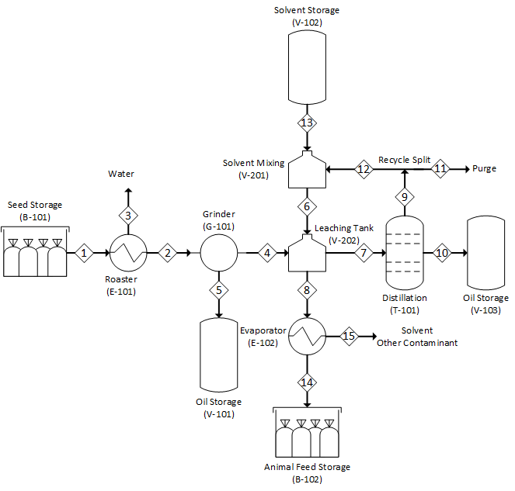
Figure 1. PFD of the process of extracting sesame oil from sesame seed.

We will like to acknowledge our faculty advisor, Professor Jeremy VanAntwerp, for guiding us through the design process and our industrial advisor, Phil Brondsema, for advising us on industrial standards and providing insights for this projects. Also, we appreciate the help we received from Professor Wayne Wentzheimer on UNISIM and also the professors in the chemistry department who were willing to answer some questions we had.

